#Transform the time series using (a) “classical decomposition” (decompose to trend and/or seasonal components)

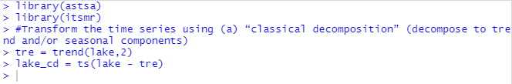

#Transform the time series using (b) “differencing”



#Plot the original time series and the transformed time series (obtained by methods (a) and (b) above).

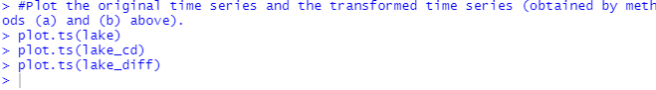

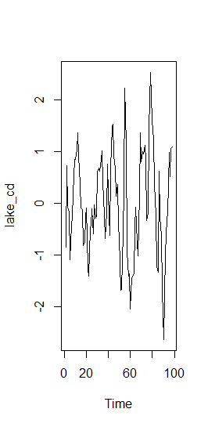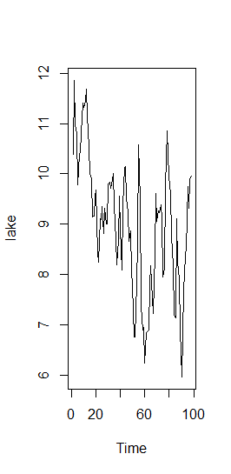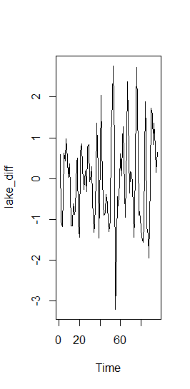

#Plot the autocorrelations (ACF) and the partial autocorrelations (PACF) of the transformed time series (obtained by methods (a) and (b) above).

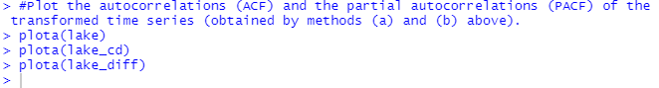

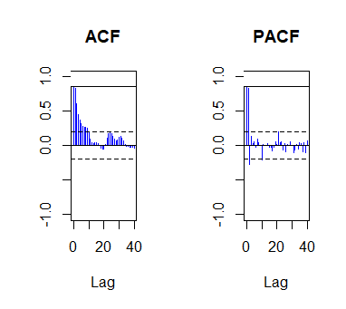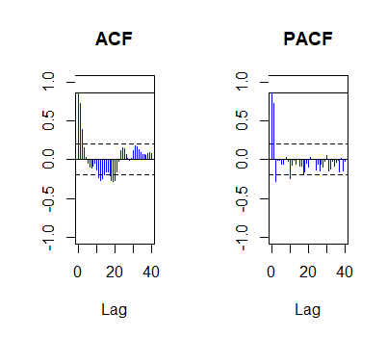

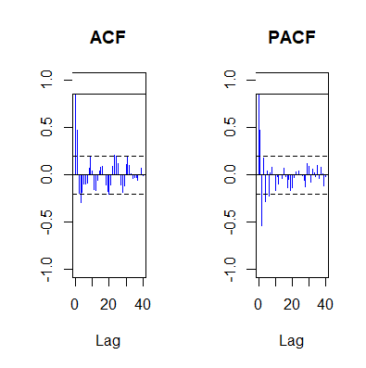

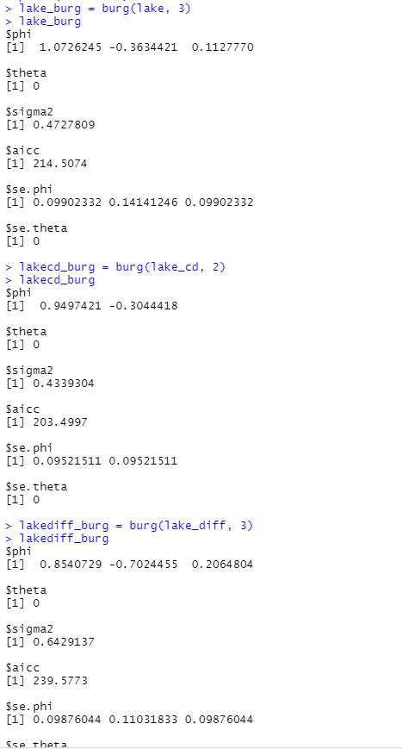

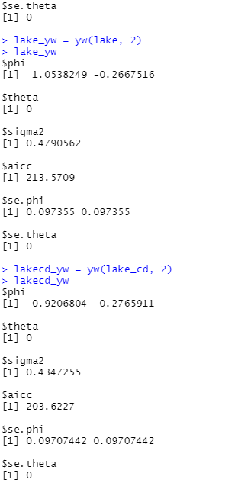

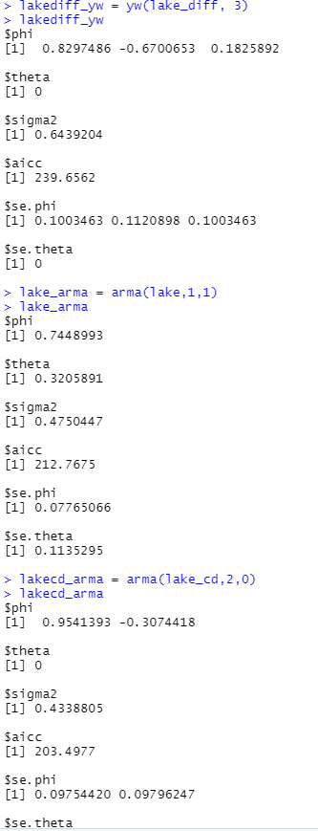

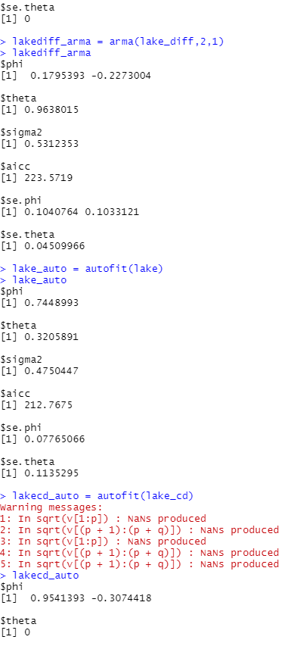

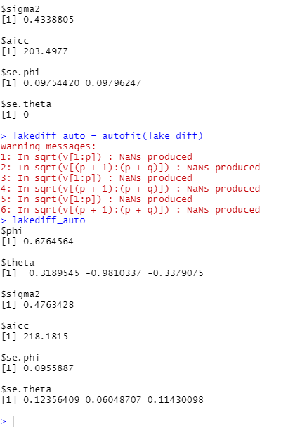

# Identify the optimal model (e.g. by using the AICC criterion).

We identify the optimal model with the help of AICC, the smaller the AIC value, the better the

model fit. Here the optimal model is lacecd_arma and lakecd_burg with AICC 203.4977 .

# equation :

Xt − φXt-1 = Zt + θZt-1 (1)

where {Zt} ∼ WN(0, σ2) and φ + θ ≠ 0.

# Check for stationarity of the residuals of the optimal model (by using test() in itsmr).

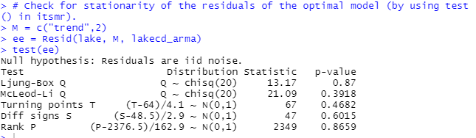

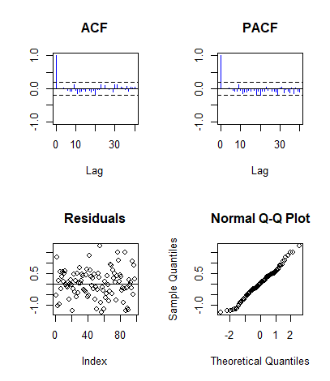

# Use “forecast()” (in itsmr) to forecast the future 10 values of the time series.

